Accessing and Exporting CCREC Data from the National Student Clearinghouse Repository

Purpose and Overview
The National Student Clearinghouse (NSC) provides a secure online repository where each GEAR UP grantee can access, review, and export their deidentified student-level data submitted through the CCREC system.

Who Can Access the Repository
Each GEAR UP grant has its own secure NSC repository account. The NSC issues unique login credentials to the Data Lead and Project Director. Additional users may be added upon request. To request additional repository user accounts, contact NCCEP’s data team (Thomas Cech) who will coordinate with NSC (Michele Gralak) to authorize and distribute credentials.
Note: Repository login credentials are separate from the secure FTP credentials used to upload student files.

Logging In to the NSC Repository
Follow these steps to access your NSC repository:
- Navigate to https://www.studentclearinghouse.org and click “User Login.”
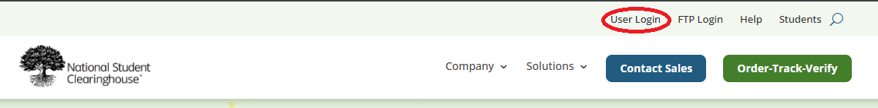

- Enter your NSC username and password (credentials provided by NSC).
- After login, you will see the main dashboard including the Submitted Files Log UI.
- Locate the link to the repository on the right-hand side of the Submitted Files Log UI. Note: If you get an error when trying to access the data repository, you may need to log out of the NSC, clear browsing data, and try again.
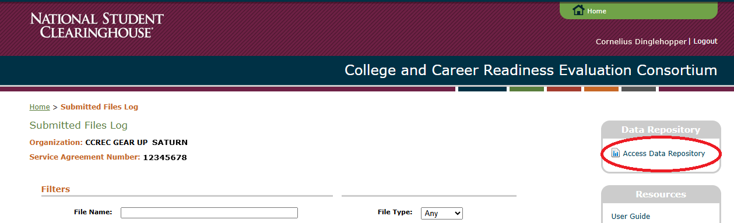

Accessing and Viewing Repository Data
Once you enter the repository, you will see a list of datasets specific to your grant. The data repository allows you to export 5 different file types: student data, service data, PSE data, AY data, and definitive view data. Each dataset corresponds to your approved submissions (e.g., CCREC Student File v2.0). Data are deidentified, meaning no student names are included, but FERPA-blocked records are retained. Users may view submission details, validation messages, and confirmation notices indicating successful uploads.
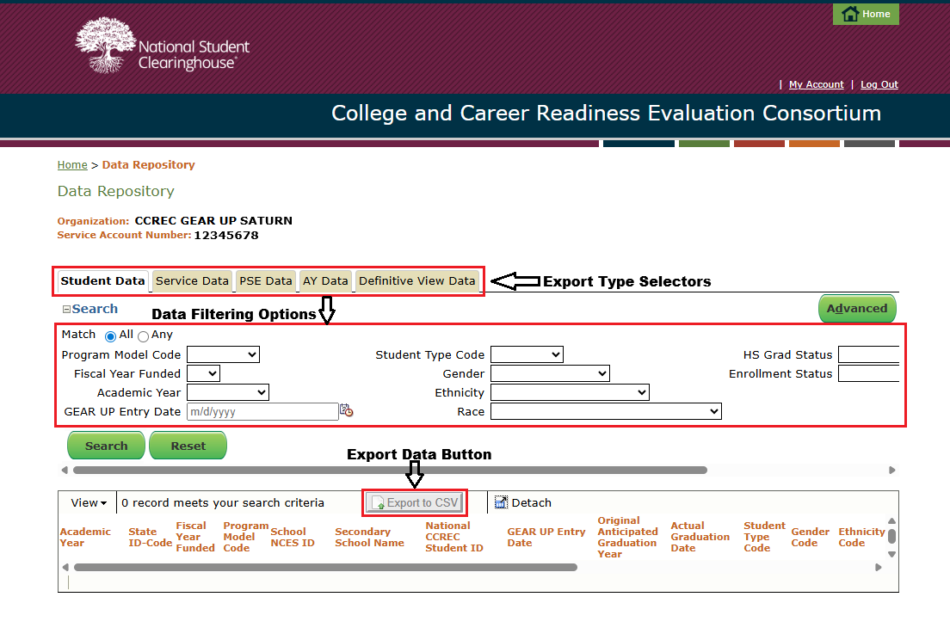

Exporting Data (CSV Format)
- Within the repository, select the dataset you wish to export.
- Locate the “Export” button or option within the repository view.
- Choose CSV format when prompted and confirm your export.
- Save the exported file securely within your organization’s designated CCREC data folder.

The exported CSV file contains deidentified records that align with your submitted student file layout. Do not share the file outside of your organization without following FERPA and data-sharing protocols.

